The Michael T. White Memorial Fund & Henry Droneburg III Memorial Art Scholarship
Proudly Present:

A Scenic Motorcycle Ride and All You Can Eat Supper!

Saturday September 25, 2010
Registration is from 1:30-2:00 at Lewistown Elementary School (address: 11119 Hessong Bridge Road, Thurmont, MD 21788)

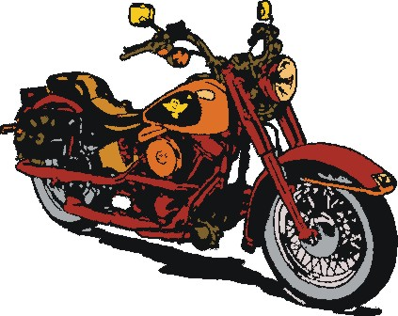
Cost: $20.00 per Person in advance or $25.00 at the door!(Children under 18 FREE!!)
Cars or other vehicles are welcome to participate in the ride. If you cannot make the ride please join us for an evening of good food, drinks, music, and prizes at the Lewistown Social Club. The event is BYOB!

The Lewistown Social Club is located at: 10540 Putnam Road
Thurmont, MD 21788

Maps & route information for the ride will be distributed upon arrival. If you have any questions or need more information please contact Cindy Droneburg at 301-748-6991 or Melissa Hawkins: 240-285-5882 or email melissa@michaeltwhite.net

