4th Annual Michael T. White Memorial Fund Poker Run

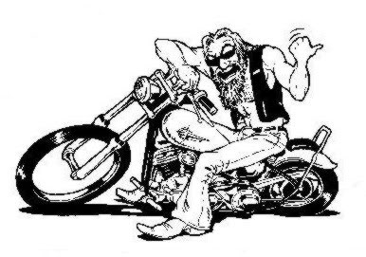

Poker Run
Saturday June 18, 2011 (rain date 6/25/11)
Registration is from 11:30-1:00 at Lewistown Elementary School (address: 11119 Hessong Bridge Road, Thurmont, MD 21788)

Cost: $20.00 per Person or $25.00 per Couple
Cars or other vehicles are welcome to participate for the above prices. All proceeds go to the Michael T. White Scholarship Fund

First Prize: 2 Tickets & 2 Pit Passes for the Nascar Sprint Cup Series
race at Richmond International Raceway on September
10, 2011

Second Prize: $75.00 Cash Third Prize: $25.00

5 Stops: The Wolfe’s Den, Blondie’s, The Ott House, Dale’s Place & Fat Boys

Door Prizes, 50/50 raffles, Free T-shirt,

Maps & route information will be obtained at registration. If you have any questions or need more information please contact Tom White at 301-845-2527 or Melissa Hawkins: 240-285-5882 or email melissa@michaeltwhite.net

